**Topic: Online Retail Application**

**Swim Wear a E-Commerce online Shopping**

**Project Planning**

**Development Team: 404**

* ***Đỗ Hùng Cường***
* ***Nguyễn Duy Vinh***
* ***Lê Thị Minh Phương***
* ***Nguyễn Thị Thủy Tiên***
* ***Lưu Minh Tín***
* ***Nguyễn Hồng Hà***

**Content**

1. **Overview…………………………………………………………………………….….3**
2. **About us………………………………………………………………………….3**
3. **Purpose of Project……………………………………………………………….3**
4. **Time………………………………………………………………………………3**
5. **Goals and Scope………………………………………………………………………...3**

**1. Project Goal…………………………………………………………………………..3**

**2. Project Scope ………………………………………………………………...............4**

1. **Organization…………………………………………………………………………….3**
2. **Resources………………………………………………………………………………..6**
3. **Hardware…………………………………………………………………………….6**
4. **Software……………………………………………………………………………...6**
5. **Developer Teams…………………………………………………………………….6**
6. **Software Requirements…………………………………………………………………7**
7. **Functional Requirements……………………………………………………………7**
8. **Non-Functional Requirements………………………………………………………8**
9. **Domain Requirements……………………………………………………………….8**
10. **System Architecture……………………………………………………………………..9**
11. **Use Cases……………………………………………………………………………...9**
12. **Architecture Diagram………………………………………………………………10**
13. **Interaction Model…………………………………………………………………...10**
14. **Risk Management………………………………………………………………………11**
15. **Project Risks.………………………………………………………………………..11**
16. **Product Risks……………….……………………………………………………….11**
17. **Business Risk………………………………………………………………………..12**
18. **Schedule…………………………………………………………………………………12**
19. **Product Backlog .…………………………………………………….……………..12**
20. **Schedule and Milestones……………………………………………………………13**
21. **Delivery Plan……………………………………………………………………………14**
22. **Abbreviations and Definitions…………………………………………………………19**
23. **Reference………………………………………………………………………………..20**

**Overview.**

1. **About us**

This part brings the information about us. We are now the senior of the International University-VNU. Our major are in Computer Science.

We make create this software to support the customers who like swim-wears, who wish to shopping online and we also support the sellers to trade their products on the Internet. Moreover, we can gain experience to graduate from university while working with this project.

Contact us: 0908998923 (Mr.Cuong) ; address: 24/7, Binh An Ward, District 2, HCM city, Vietnam.

1. **Purpose for this project.**

The purpose of this e-commerce project is creating a webpage online for the sellers and the customers to trade the swim-wear on the internet.

The new software goes along with new and different functions. People can view the detail of the swim-wear, search and buy swim-wear online

1. **Time**

This project will be done in about one month. The started date is 16/11/2016 and the deadline is 19/12/2016

**Goals and Scope.**

1. **Project Goals**

For some shop managers, managing the customers or products is always bringing to them many troubles. Sometimes, the shops have difficulties in contacting with the customers, determining the total payment then the bill has to be printed or written for customers. Specially, you will realize that it can be unsafe and waste your time if these are traditionally the paper and pen works. To help shop managers solving their problems, we have created a web application called “Swim Wear a E-Commerce online Shopping” or 404 project in short. A Web based application that help the sellers and the customers to trade the swim-wear on the internet. Thank to our website, it is very convenient for the customers and the sellers to buy/sell the products (swimwear). The customers can save a lot of time by shopping online, they don’t need to come to the shop to buy the swim wears. Moreover, customers can pay for the bill by their bank account, and the bill is displayed for the customers after payment successful. The system also saves the transaction of customers and they can receive their orders by delivering system. In addition, another goal of our website is saving the money. Thank to shopping online, the investment is reduce, the owner of the shop don’t need to build a big shop, and also reduce the number of staff. Therefore, the price of products will be better for customers.

1. **Project Scope**
   1. Included:

|  |  |  |  |  |
| --- | --- | --- | --- | --- |
| Feature | Release 1 | Release 2 | Result | |
| FE-1 | Fully showing all the swim wears in each category available in shop for the user | Adding the search functions. | Fully implemented. |
| FE-2 | Implement login/logout function | Adding “register” function. | Fully implemented |
| FE-3 | Implement pay bill function for customer | Adding “view transaction” function. | Fully implemented. |
| FE-4 | Implement manage customer function for administrator | Adding “edit profile” function. | Fully implemented. |
| FE-5 | Implement update product function for administrator | Adding “add new product” function, “delete product”, “edit product” function | Fully implemented. |
| FE-6 | Implement shopping cart for customer | Adding “add product to cart” function and “remove product from cart” function | Fully implemented. |

* 1. Excluded

Ex1: We do not implement the function “vote products” and “comments” for the customer

Ex2: For the administrator system, we don’t show the report which include the activity of customer during a day or a week for administrators, if they want to view the transaction of a customer, they have to select each customer to view.

**Organization.**

1. **Organizational Boundaries and Interfaces**

Due to the size of our software group, management will be divided in the following manner: The Product Manager is Đỗ Hùng Cường. Nguyễn Hồng Hà will follow Cường's direction of the product. The Documentation Manager is Đỗ Hùng Cường. All documentation created by Đỗ Hùng Cường and Nguyễn Hồng Hà will be reviewed by Đỗ Hùng Cường.

There are some meeting will be called with all the members of the engineering team every Saturday afternoon to separate the job for every member. The supplier is the 404 company, a swimwear shop.

**2. Project organization**

This part describes the role of each member in project team. Each member is work for each field and need to responsible for their task. For further information, please contact the members below.

|  |  |  |
| --- | --- | --- |
| Members | Position | Email |
| Đỗ Hùng Cường | Project Manager, Designer, Coder, Technical Writer | cuongvip1295@yahoo.com.vn |
| Nguyễn Hồng Hà | Document Writer, Tester, Designer, QA Engineer | nhha.ityu@gmail.com |
| Lê Thị Minh Phương | Designer | minhphuogbrow@gmail.com |
| Nguyễn Thi Thủy Tiên | Designer | nguyethithuytien711@gmail.com |
| Lưu Minh Tín | Designer | hoichimbeo@gmail.com |
| Nguyễn Duy Vinh | Designer | dacnhantam1607@gmail.com |

**Resources.**

Resource is thins that helps us to build this websites. It is the important part beside out potentials. We break it into 3 parts which are: Hardware, Software and Developers

1. **Hardware**

|  |  |
| --- | --- |
| Device | Details |
| Intel Core i5 4200 CPU 2.3Hz | Processor |
| Intel Core i7 3537U CPU 2.0Hz | Processor |
| DDR3 | 8GB RAM |
| Intel Graphics MH4400 | Card |
| Intel High Definition Audio | Audio and Speaker |
| Genius | Mouse |
| HD 15.6 inch | Monitor |

1. **Software**

|  |  |
| --- | --- |
| Device | Details |
| Window 7 professional 64 bits | Operating System |
| Microsoft Office 2013 Professional | Document Application |
| Adobe Dreamweaver CS6 | Design Tools |
| Eclipse Mars, NetBeans | Programmer Tools |
| MySQL, Navicat | Database Tools |
| Google Chrome, Cốc Cốc,  Mozilla Firefox, Internet Explorer | Testing Tools |

1. **Developers Teams**

|  |  |
| --- | --- |
| Person | Details |
| Đỗ Hùng Cường | Language: java, C/C++, javascript, xml  Technique: website developer, GUI designer  Project: swimwear project (404 project)  Position: team leader, programmer, designer |
| Nguyễn Hồng Hà | Language: java, C/C++, javascript  Technique: website developer  Project swimwear project (404 project)  Position: tester, designer, QA engineer |
| Lê Thị Minh Phương | Language: java, C/C++  Technique: website developer  Project: swimwear project (404 project)  Position: designer |
| Nguyễn Thi Thủy Tiên | Language: java, C/C++  Technique: website developer  Project: swimwear project (404 project)  Position: designer |
| Lưu Minh Tín | Language: java, C/C++  Technique: website developer  Project: swimwear project (404 project)  Position: designer |
| Nguyễn Duy Vinh | Language: java, C/C++  Technique: website developer  Project: swimwear project (404 project)  Position: designer |

**Software Requirement.**

**I. Functional Requirements**

**This part brings you the function of our systems briefly. We will show you the details in the Requirement Specification document. In this part, you will have the basic idea what our website can support you.**

**There are total 12 functions in our website:**

1. **Registration.**

The Guests who wish to have a shopping list should have an account. Registration was born for this problem. Users use their personal information to register an account.

1. **Login.**

Users use their email and password to login and perform other activities in the website.

1. **Log out.**

When users finish their works on the website, they should have log out to prevent their account from robbery.

1. **View Product information.**

The webpage show the swim wear lists and the customers can click to each product of the list to see full details about this product. List of product will only show the type, brand, name, category….

1. **Search Products.**

This function supports the customers to find their needed products faster. Users can search by type, brand, name, category….

1. **Edit Profile.**

Users who want to change their information can use this function. They can change name, password, address… Users cannot change is email, and the customers cannot change their bank account.

1. **Add Product to Cart.**

Customers choose the swim wear that they want to buy and then add to their shopping cart.

1. **Delete Product from Cart.**

Customers want to delete the swim wear they have ordered in the shopping cart.

1. **Pay Bill.**

Customers want to pay for their orders and receive the product.

1. **View Transaction.**

Customers can view their transaction list which products, quantities they had paid for and date & time they had done their transaction.

1. **Update product.**

This function is only available for the administrators. They can add new product to the website or delete, edit product information.

1. **Manage Customers**

This function is only available for the administrators. They can manage customer accounts delete account if it is not active for a long time or edit customer profile (if necessary).

**II. Non-Functional Requirements.**

|  |  |
| --- | --- |
| Property | Measure |
| Environment | The system is developed on J2EE framework.  Client-side programming language: HTML, CSS, Javascript.  Server-side programming language: Java ( java Bean, Servlet and JSP)  Database: MySQLhandle with Navicat. |
| Speeds | 0.1s for response time.  0.5s for process transactions. |
| Reliability | Invalid inputs will cause invalid results or errors. |
| Stability | The system must be stable if the numbers of users increasing |
| User Interface | Attractive and interesting, ignore boring interface. |
| Support | Our team will not only maintain the website but also help administrators manage the websites. |

**III. Domain Requirements.**

Websites policies will be public so that users can follow the rules of websites.

The language used in the website is English. E-commerce websites is an international websites which used by different people in different countries that have different languages but English is the most popular language in the world. To let every people access your websites, English must be used!

**System Architecture.**

1. **Use Cases**

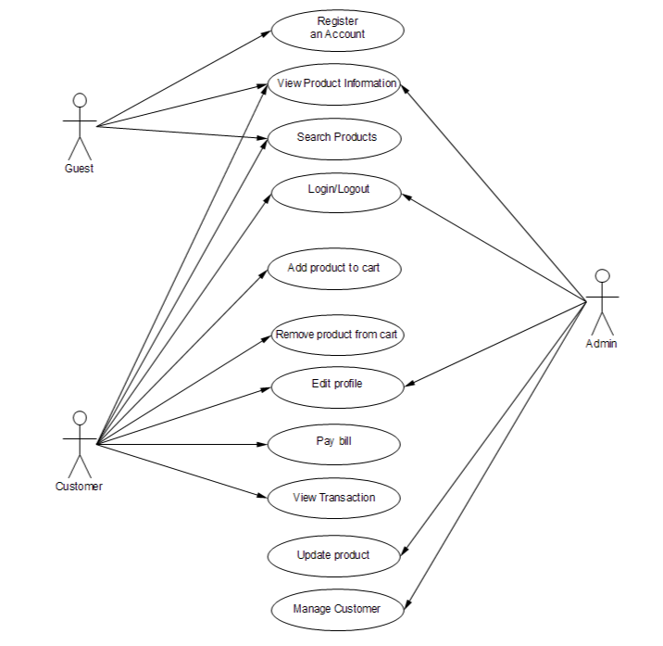

1. **System Architecture**

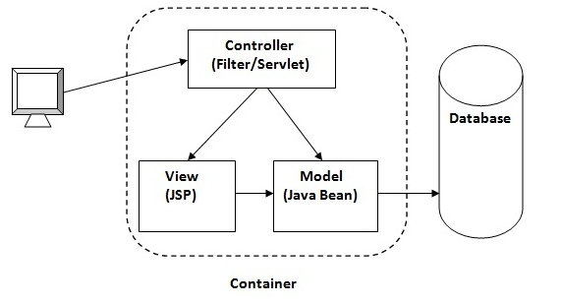

1. **Entity Relationship Diagram**

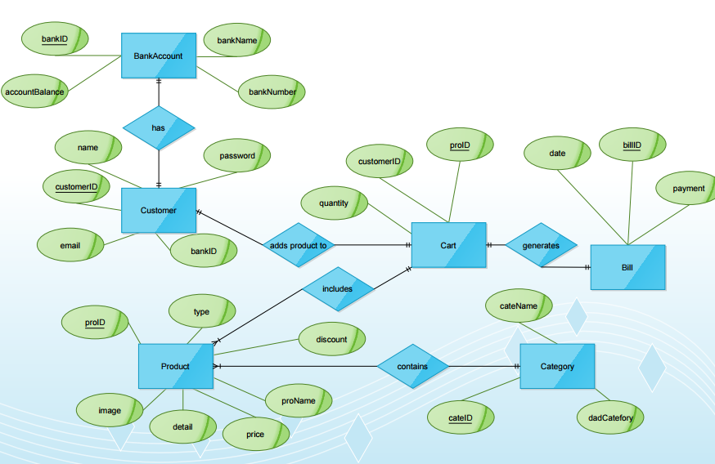

**Risks Management.**

This part brings you the risk that our teams may have and how to overcome it. We break down this section in three small parts: Project Risk, Product Risk and Business Risk.

Let’s take a look what our team has to face and how us handle this

1. **Project Risks**

|  |  |  |
| --- | --- | --- |
| Risk | Details | Solutions |
| Weak Connections. | Members have not worked together before or do not understand how others work. | Our teams have to unite and work together. Give away the personality and respect the idea of the teams. |
| Less Meeting. | Members live far away from each other and do not have much time for working together. | We use facebook, email, skype to communicate and Teamviewer for strongly things. |
| Members Problems. | Some members have an illness or have personal problem. It makes the problem delay for a while. | Others member replace their work until they come back for working. |
| High Technology. | Some technology that our team has not known but it is helpful for our website. | Learning about it as quick as possible. If not, it makes the project delay for a while. |
| Hardware. | Virus or hacker attack members and stole data. It makes the project delay for a while. | Use antivirus program and save information online. |

1. **Product Risks**

|  |  |  |
| --- | --- | --- |
| Risk | Details | Solutions |
| Component Compatibility. | Component is not compatible to run. | Using extreme programming in agile method to have a compatible component. |
| Changing Requirement. | Customers change their requirement. | Using Scrum model, customers should follow the team from the begin day. |
| Error when executing. | Program runs in error or cannot run. | When our team finished a function, we should test and check carefully before building next function. |
| Expiry Time. | Project cannot finish on time. | Each member tries to work as hard as they can to finish their task on time. |

1. **Business Risk**

|  |  |  |
| --- | --- | --- |
| Risk | Details | Solutions |
| Customer leaves the teams. | Customers cannot work with the team anymore. They have to leave. | Our projects have a cycles method to cope with this challenge. Moreover, we can contact with customer through email or skype. |
| Environment Changing. | Customers ask the teams use other programming language or runs program in different environment. | This is a big problem. Customer must decide in the 1st day. If not, they should leave the project. |
| Delaying Project | Customers delay in supplying materials or money for the teams. | The team tries to manage to continue the projects but if it happens for a long time, project should be delay. |

**Schedule**

1. Product Backlog

|  |  |  |  |  |
| --- | --- | --- | --- | --- |
| No | As a/an | I can… | So that… | Notes |
| 1 | Users/guess | Register for an account | I can login to the website and experience full functionality of the website | Every people can create the account of the website basing on email and using bank account to pay |
| 2 | User/guess/customer/admin | View product information | I can see clearly and exactly what I want to buy | Users must click on the product to go to product page |
| 3 | User/guess/customer | Search product | I can find a product quickly, of check if the product I want was available in this website | There will be high function search after the “search by name” function |
| 4 | User/guess/admin | Login to the website | I can experience more feature of the website | User/guess/admin must have available registered account stored in the database |
| 5 | User/guess/admin | Logout from the website | I can protect my account after I finish my work on the website | Customer/admin must have been logged in first |
| 6 | Customer | Add product to cart | I can later buy the chosen products in the cart page with my bank account | Customer must log in to have this function |
| 7 | Customer | Remove products from cart | I don’t have to buy products I don’t like | Customer must have products in the Cart |
| 8 | Customer/admin | Edit profile | I can adjust information about myself or change my address to help delivering or change password | Customer/admin must have been logged in first |
| 9 | Customer | Pay bill | I can purchase the product I ordered in Cart | Customer’s bank account must be enough to make the transaction work |
| 10 | Customer | View transaction | I can see what I bought, how much I spent, and the time I purchased the products | Customer must have been logged in first |
| 11 | Admin | Update product | I can update information on product such as: price, discount, etc… Or I can delete some unwanted product | Admin must have been logged in first |
| 12 | Admin | Manage customer | I can adjust information for the customers or delete | Admin must have been logged in first |

1. Schedule and Milestones

|  |  |  |  |  |  |  |  |  |  |  |  |  |  |  |  |  |  |  |  |  |  |  |
| --- | --- | --- | --- | --- | --- | --- | --- | --- | --- | --- | --- | --- | --- | --- | --- | --- | --- | --- | --- | --- | --- | --- |
| Id | Task name | Start | Finish | November 2016 | | | | | | | | | | December 2016 | | | | | | | | |
| 1 | 5 | 8 | 11 | 14 | 17 | 20 | 23 | 25 | 29 | 2 | 4 | 7 | 9 | 11 | 13 | 15 | 16 | 17 |
| 1 | Design interface | 1/11/2016 | 4/11/2016 |  |  |  |  |  |  |  |  |  |  |  |  |  |  |  |  |  |  |  |
| 2 | Register/Login/Log Out | 5/11/2016 | 7/11/2016 |  |  |  |  |  |  |  |  |  |  |  |  |  |  |  |  |  |  |  |
| 3 | Design database for user | 8/11/2016 | 10/11/2016 |  |  |  |  |  |  |  |  |  |  |  |  |  |  |  |  |  |  |  |
| 4 | User database connection | 11/11/2016 | 13/11/2016 |  |  |  |  |  |  |  |  |  |  |  |  |  |  |  |  |  |  |  |
| 5 | View overall product list | 14/11/2016 | 16/11/2016 |  |  |  |  |  |  |  |  |  |  |  |  |  |  |  |  |  |  |  |
| 6 | View product in details | 17/11/2016 | 19/11/2016 |  |  |  |  |  |  |  |  |  |  |  |  |  |  |  |  |  |  |  |
| 7 | Testing | 20/11/2016 | 22/11/2016 |  |  |  |  |  |  |  |  |  |  |  |  |  |  |  |  |  |  |  |
| 8 | Searching | 23/11/2016 | 24/11/2016 |  |  |  |  |  |  |  |  |  |  |  |  |  |  |  |  |  |  |  |
| 9 | Shopping cart ( add to cart, remove from cart) | 25/11/2016 | 28/11/2016 |  |  |  |  |  |  |  |  |  |  |  |  |  |  |  |  |  |  |  |
| 10 | Pay bill | 29/11/2016 | 1/12/2016 |  |  |  |  |  |  |  |  |  |  |  |  |  |  |  |  |  |  |  |
| 11 | Testing | 2/12/2016 | 3/12/2016 |  |  |  |  |  |  |  |  |  |  |  |  |  |  |  |  |  |  |  |
| 11 | Design database for products | 4/12/2016 | 6/12/2016 |  |  |  |  |  |  |  |  |  |  |  |  |  |  |  |  |  |  |  |
| 12 | Products database connection | 7/12/2016 | 8/12/2016 |  |  |  |  |  |  |  |  |  |  |  |  |  |  |  |  |  |  |  |
| 13 | Admin update product | 9/12/2016 | 10/12/2016 |  |  |  |  |  |  |  |  |  |  |  |  |  |  |  |  |  |  |  |
| 14 | Admin delete product | 11/12/2016 | 12/12/2016 |  |  |  |  |  |  |  |  |  |  |  |  |  |  |  |  |  |  |  |
| 15 | Admin checking quantity of products | 13/12/2016 | 14/12/2016 |  |  |  |  |  |  |  |  |  |  |  |  |  |  |  |  |  |  |  |
| 16 | Admin manage user accounts | 15/12/2016 | 16/12/2016 |  |  |  |  |  |  |  |  |  |  |  |  |  |  |  |  |  |  |  |
| 17 | Recommend/contact/feedbacks | 16/12/2016 | 17/12/2016 |  |  |  |  |  |  |  |  |  |  |  |  |  |  |  |  |  |  |  |
| 18 | Testing +Report | 17/12/2016 | 18/12/2016 |  |  |  |  |  |  |  |  |  |  |  |  |  |  |  |  |  |  |  |

|  |  |  |  |
| --- | --- | --- | --- |
| **Code** | **Milestone** | **Date** | **Description** |
| M01 | Review 1 | 15/11/2016 | Finish Initiation Phase |
| M02 | Review 2 | 28/112016 | Finish Requirement Definition Phase |
| M03 | Review 3 | 05/12/2016 | Finish Development & Testing Phase |
| M04 | Review 4 | 19/12/2016 | Finish Project Closure |

**Delivery Plan. (Sprint Backlog)**

|  |  |  |  |  |  |  |
| --- | --- | --- | --- | --- | --- | --- |
|  | Task | Work | Time | Start | Finish | Assigned |
|  | 1 | Design user interface | 3 days | 1/11/2016 | 4/11/2016 | Cường |
|  | 2 | Register/Login/Log Out | 2 day | 5/11/2016 | 7/11/2016 | Tiên+Tín+Phương |
|  | 3 | Design database for user | 2 days | 8/11/2016 | 10/11/2016 | Vinh+Tín |
|  | 4 | User database connection | 2 day | 11/11/2016 | 13/11/2016 | Tiên+Vinh |
|  | 5 | View overall product list | 2 days | 14/11/2016 | 16/11/2016 | Cường |
|  | 6 | View product in details | 2 days | 17/11/2016 | 19/11/2016 | Hà |
|  | 7 | Testing | 2 day | 20/11/2016 | 22/11/2016 | Hà |
|  | 8 | Searching | 1 day | 23/11/2016 | 24/11/2016 | Tín+Tiên |
|  | 9 | Shopping cart ( add to cart, remove from cart) | 3 days | 25/11/2016 | 28/11/2016 | Hà+Tiên |
|  | 10 | Pay bill | 2 days | 29/11/2016 | 1/12/2016 | Cường |
|  | 11 | Testing | 1 day | 2/12/2016 | 3/12/2016 | Hà |
|  | 11 | Design database for products | 2 days | 4/12/2016 | 6/12/2016 | Tín+Phương |
|  | 12 | Products database connection | 1 day | 7/12/2016 | 8/12/2016 | Hà+Tiên |
|  | 13 | Admin update product | 1 day | 9/12/2016 | 10/12/2016 | Cường |
|  | 14 | Admin delete product | 1 day | 11/12/2016 | 12/12/2016 | Cường |
|  | 15 | Admin checking quantity of products | 1 day | 13/12/2016 | 14/12/2016 | Hà+Cường |
|  | 16 | Admin manage user accounts | 1 day | 15/12/2016 | 16/12/2016 | Cường |
|  | 17 | Recommend/contact/feedbacks | 1 day | 16/12/2016 | 17/12/2016 | Tín+Phương+Tiên |
|  | 18 | Testing +Report | 1 day | 17/12/2016 | 18/12/2016 | Cường+Hà |
|  |  |  | **Total: 30 days** |  |  |  |

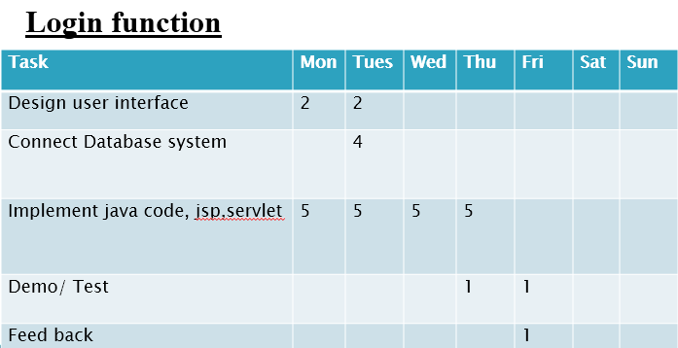

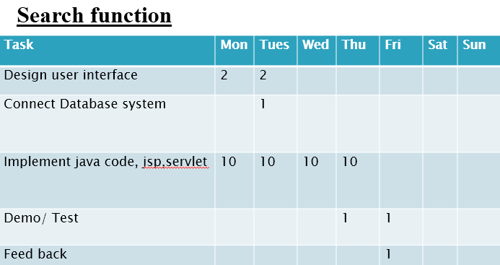

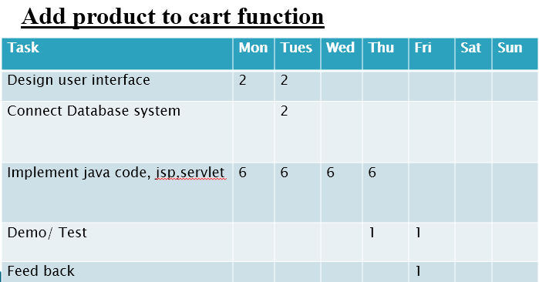

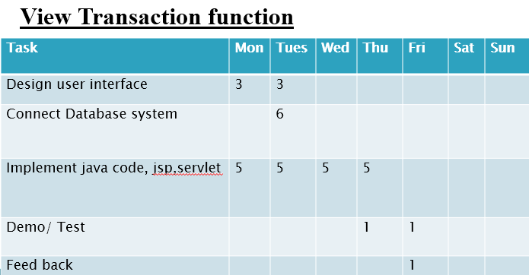

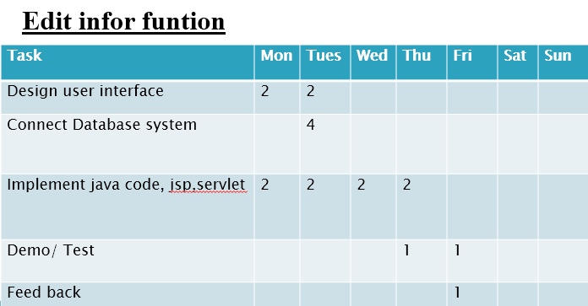

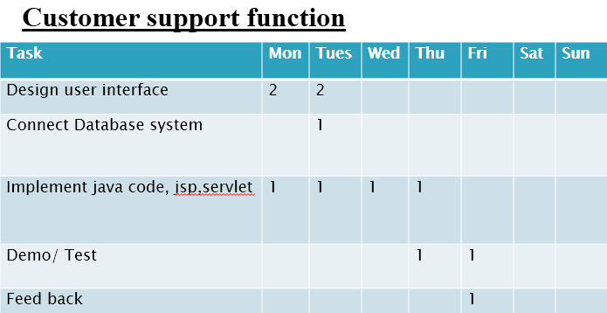

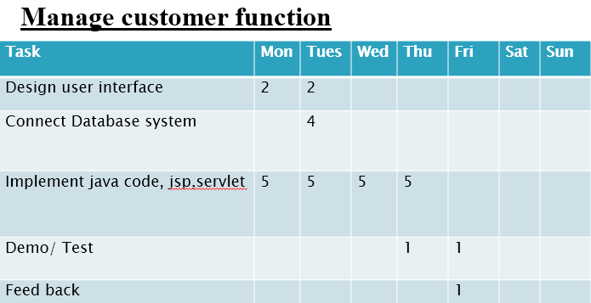

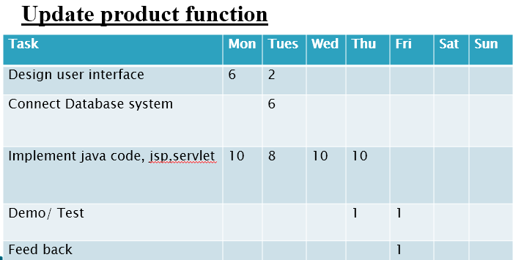

**Abbreviations and Definitions**.

|  |  |
| --- | --- |
| Term | Descriptions |
| Customer | The customer’s interface |
| Admin | The administrator’s interface |
| Product | Swimwear item/swimwear product |
|  |  |
| Cart | Where customer (add /remove) products (its contains the list of products ordered by customer) |
| Transaction | The list of bill that contains customer information and product information with quantity, price and also has total payment and payment-date |
| Pay bill | It is a term which is used to point to all the information of the order that the customer chosen including the price of each product by the current customer account. |
| Search | Customer can search the product by brand, type, name, price and discount. |

**Reference**.

https://blackboard.hcmiu.edu.vn/bbcswebdav/pid-30297-dt-content-rid-95144_1/courses/IT076IU_1_20161701/AsstSpec.pdf

* Project Plant template – post by Mrs. Nguyễn Thị Thanh Sang on blackboard.hcmiu.edu.vn
* https://www.ciwebgroup.com/website-design-project-plan/
* Team Discussion